Week 9 Lecture 2

Previous Lecture
- Pointers

Today’s Lecture
- more pointers
- Linked list
Relationship between Pointer & Array
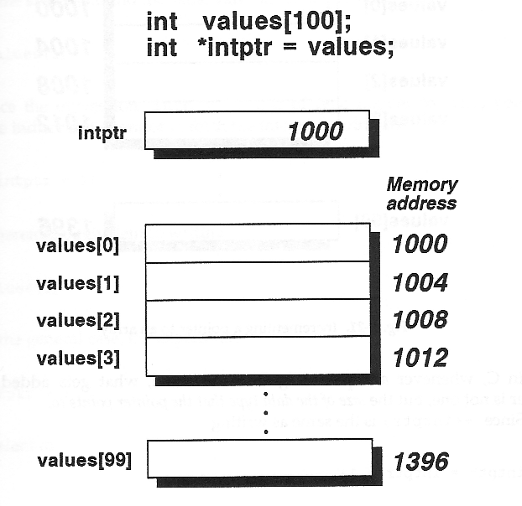
Relationship between Pointer & Array
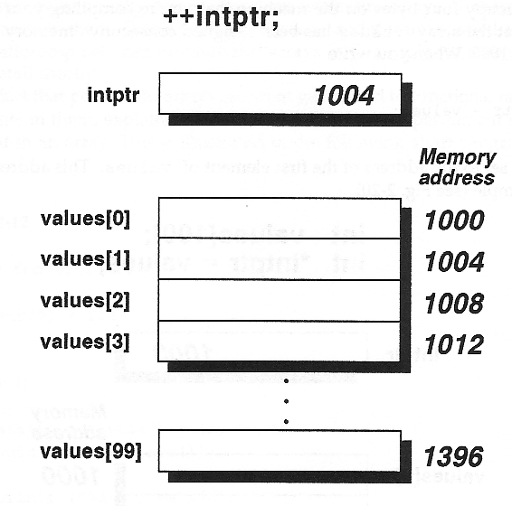
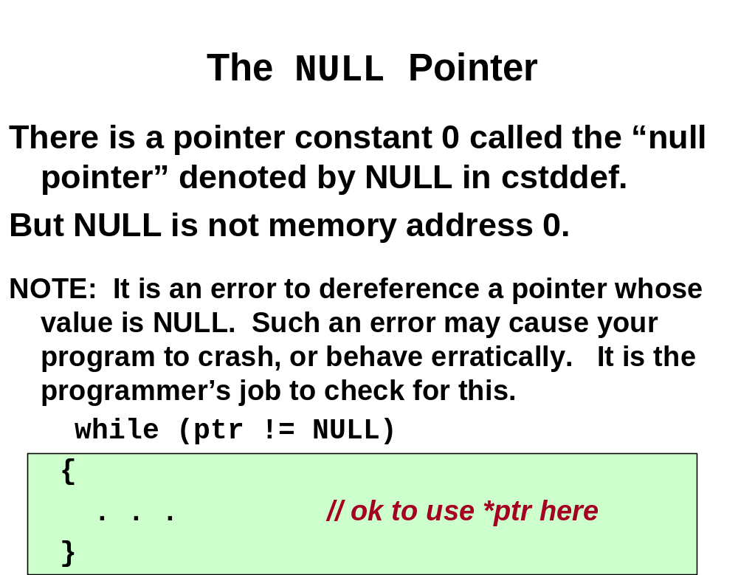

‘this’ pointer
1. Each object gets its own copy of the data member.
2. All access the same function definition as present in the code segment.
Compiler supplies an implicit pointer along with the functions names as ‘this’.
The ‘this’ pointer is passed as a hidden argument to all nonstatic member function calls and is available as a local variable within the body of all nonstatic functions. ‘this’ pointer is a constant pointer that holds the memory address of the current object. ‘this’ pointer is not available in static member functions as static member functions can be called without any object (with class name).
Linked Lists
- It is a sophisticated data structure for lists built by pointers
- Procedures
- Decide what each entry of the list is to look like
- Define a structure that describes such a list entry
- Reserve one or more members
- Singly linked list: one pointer member
- Doubly linked list: two pointer members
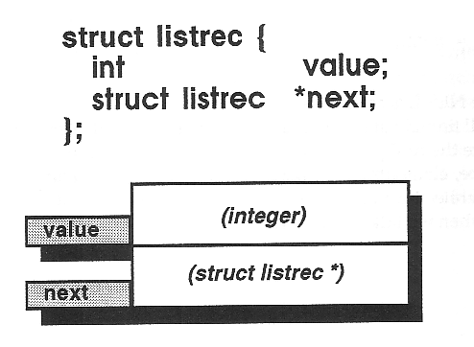
Singly Linked Lists
Singly Linked Lists
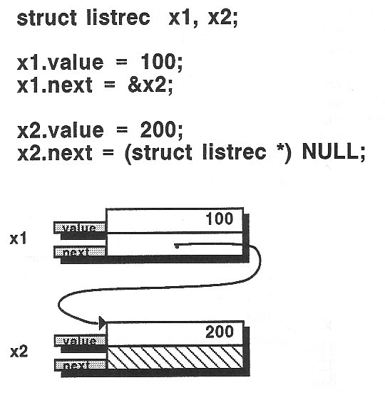
Add an Element to a Linked List
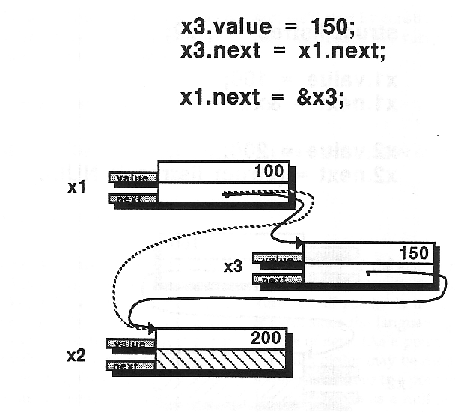
Remove an Element to a Linked List
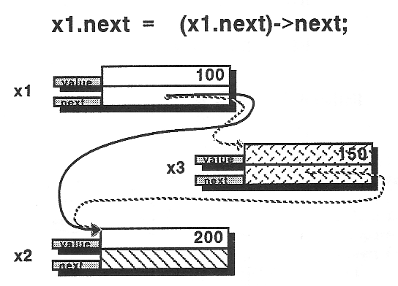
Search a Linked List
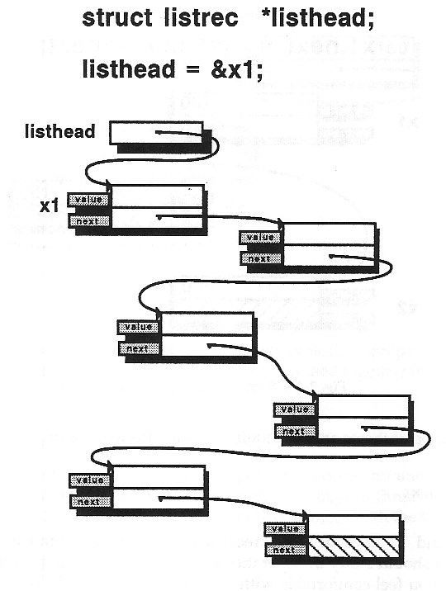
Search a Linked List

// search linked list for specified value

struct listrec *search (struct listrec *listptr, int match)
{
while ( listptr != NULL)
if( listptr->value == match)
break;
else
listptr = listptr->next;

return(listptr);
}
2-Dimensional Arrays & Arrays of Pointers
char days[7][10] = { “Sunday”, “Monday”, “Tuesday”,
“Wednesday”, “Thursday”, “Friday”, “Saturday” };

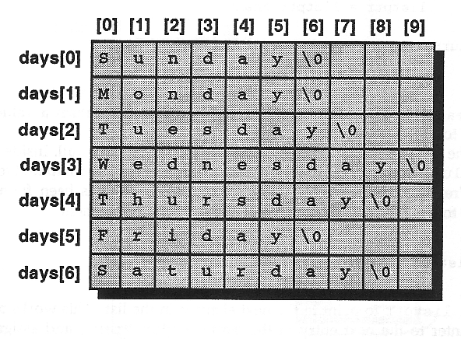
2-Dimensional Arrays & Arrays of Pointers
- days[0][0]…days[0][9] ←→ *days[0]
- to display the first row
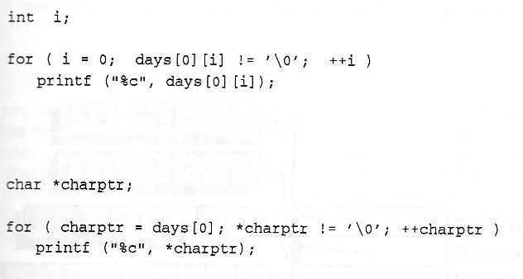
2-Dimensional Arrays & Arrays of Pointers
char *days[7] = { “Sunday”, “Monday”, “Tuesday”,
“Wednesday”, “Thursday”, “Friday”, “Saturday” };
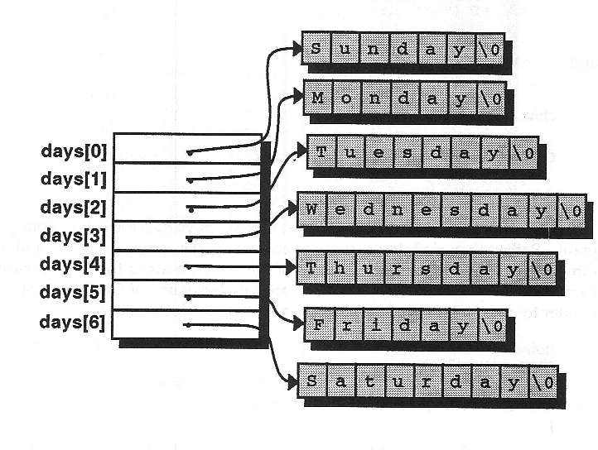
2-Dimensional Arrays & Arrays of Pointers

char linetab[1000][257];

char *linetab[1000];

Pointers to Pointers
- Pointers can be used to point other pointers

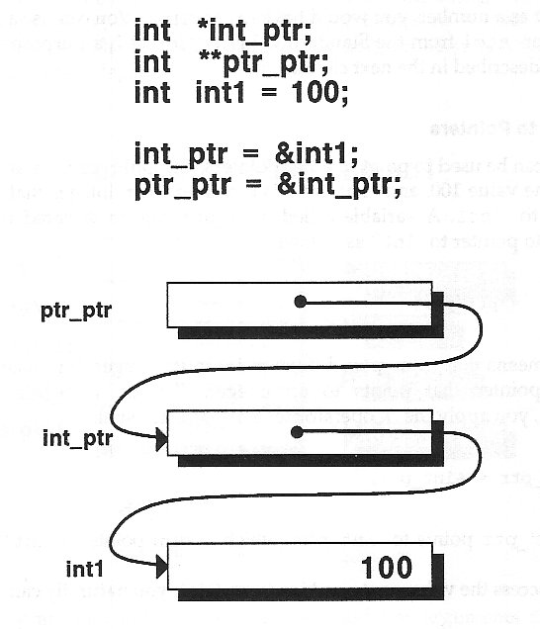
Pointers to Pointers
- Pointers to pointers can be used to dynamically allocate a 2-dimensional array
int **array = new (int *)[nrows*sizeof(int *)];
For(i=0; i<nrows; i++)
*array[i] = new int[ncols*sizeof(int)];

- int **array ←→ array[row][column]
- int ***array ←→array[row][column][width]
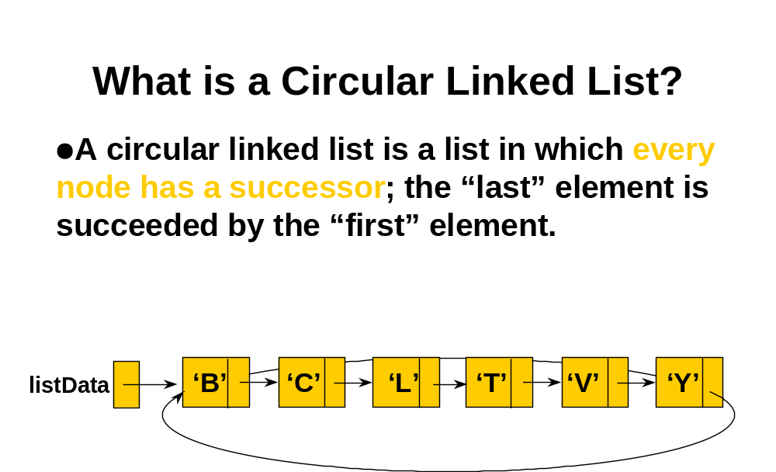
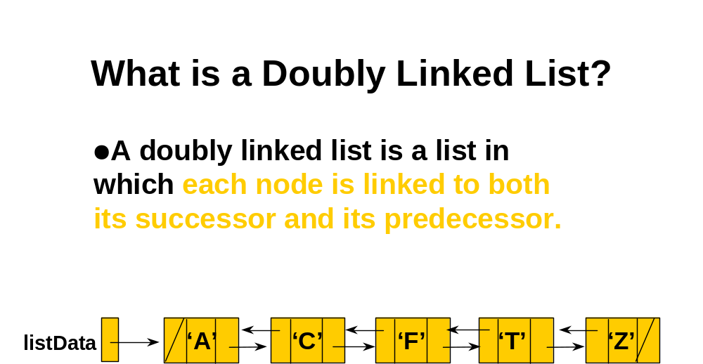

Doubly Linked List

struct listrec
{
int value;
struct listrec * prev;
struct listrec *next;
};
